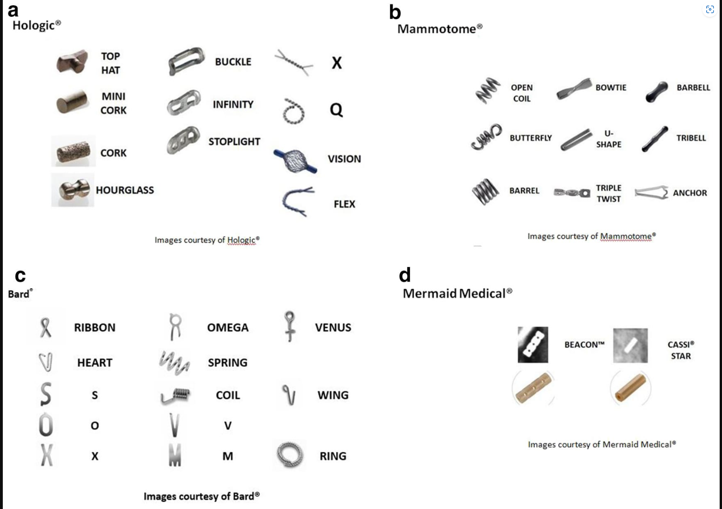
https://cpb-us-w2.wpmucdn.com/voices.uchicago.edu/dist/4/945/files/2018/12/Breast-Clips-1zk9vgx.jpg

